Derivaz – Smoke and Regression Test Pipeline Documentation

1. The pipeline’s motto is to have smoke and regression tests on a specifically built separate environment (identical to latest frontend of website).
2. Pipeline is divided into below stages :
- Git checkout :
- We have used gitlab-Jenkins integrated defined variables along with the webhook trigger. Once webhook is activated, it will consider the source repository details in the form of gitlab variables.
Documentation link:
https://github.com/jenkinsci/gitlab-plugin#introduction
- Sonarqube analysis :
- It will scan the latest cloned code for vulnerability checks, code smells, quality gates and have report on its front dashboard. In pipeline, we are copying the cloned repo contents to a separate directory, and at that location we are running the sonar scan. This is done because, the sonar needs dev dependencies to be installed and it creates ‘node_modules’ directory which coincides with the same named directory while building the source code. The chances of build getting failed are high.
- Sonarqube is running on a docker container with latest v9.9 separately on other EC2 instance.
- Code build :
- The source code is being built freshly everytime in angular js and npm builds and the build artifacts are stored in ‘build.tar’ file in the jenkins job workspace directory itself.
- The sonarqube and code build stages are run and built in parallel execution
- Containerizing and Hosting our test Env :
- The build.tar artifact is extracted and the contents are copied into Docker container. After extraction we get a folder named browser and inside we have our contents. For this we have a Dockerfile with nginx image, copy our extracted contents from the browser dir into /usr/share/nginx/html location of Docker container + copy a config file into same location.
Build the image, tag the image with your dockerhub account tag and run the image using that tag.
- Tagging is important because out test-suite files will be having package.json, domains.json & utility.ts files in which we’ll be mentioning the test env details.

Refer below images for above files and data added in highlighted mode
Test-suite files are in dev branch -> ui -> tests
Refer the paths showing in repo for file identification

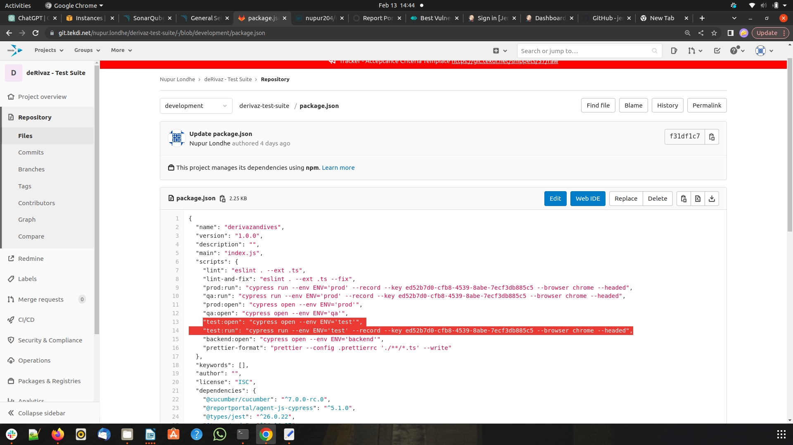
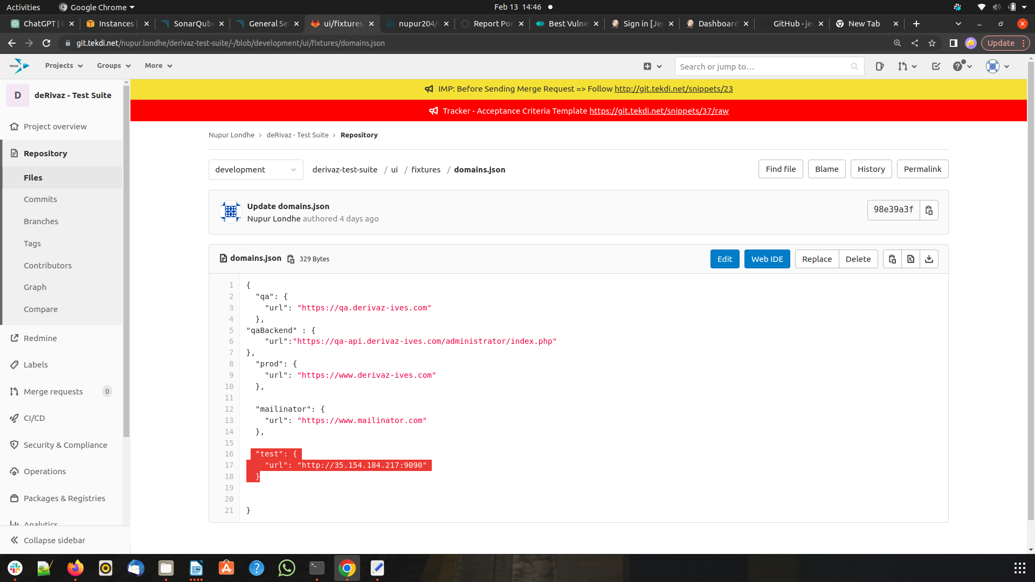
- Running containerized Cypress tests :
- We have Dockerfile with latest cypress 12.5 image, install npm, report portal and overall update and copy out test-suite files in the /app directory inside container and run the image with your cypress test commands (more details in cypress dockerization documentation).
- We have a Jenkins Master-Slave configuration in place, hence the Sonarqube server is set-up on this slave and Cypress docker container is having latest build cypress image on it and container is running on the same.
- Deletion of Environments :
- Stop and remove the containers created, delete the docker images (only test env images, not cypress) built.
- Post Build actions :
- Although the post build action script is written at the starting of the pipeline, it will be executed at the end of the successful or failed build.
- It is the script which will publish your pipeline build status back to Gitlab Source repo as well as to the MR approver.

